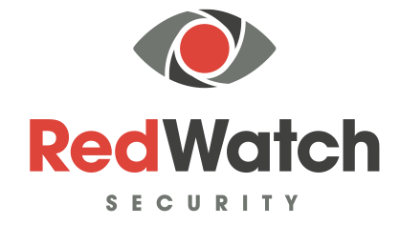 | COVID-19  STATEMENT

COVID 19 – PROTECTING OUR CUSTOMERS/CLIENTS

CORONAVIRUS (COVID-19) UPDATED STATEMENT FOR OUR CLIENTS
As you all know, we have all been facing a serious situation caused by the fast spread of the Coronavirus (Covid-19) so we have prepared this statement to keep our clients informed about our plans and preparations for our business continuity.
Things are slowly starting to re-open but will be with procedures and measures put in place so it is important to follow the Government guidelines.
In general, advice about the virus and health precautions can be found at:

https://www.nhs.uk/conditions/coronavirus-covid-19/

https://www.gov.uk/guidance/coronavirus-covid-19-information-for-the-public

The measures, already implemented, have been to:

Keep our staff informed
A statement has been issued to all staff providing them with advice on the virus, its symptoms and immediate precautionary steps that they need to take. They have been given the current NHS guidance to help prevent the spread of the virus.
We are monitoring the government and NHS guidance on a daily basis and will send regular updates to our officers and office staff so that they always have the latest data

Our mobile patrol team already carry gloves and masks as standard because of the condition of some buildings which they enter. These can be made more widely available if it is deemed necessary but currently there is no evidence or advice which suggests this is a beneficial step at present.

MANTAINING OUR SERVICES

We recognise the future has challenging times ahead of us filled with uncertainty, but we believe communication is the key to ensuring and maintaining our services and will do our upmost to make sure all standards are met during this covid-19 outbreak.

We will share all information as and when needed in the foreseeable future regarding this critical time either via email or over the phone.

QUARANTINE OF OUR OFFICERS

We will update you on any of our Officers that are self-isolating or feel that COVID -19 is affecting our ability to secure or operate on any of your sites. We will do our upmost to work with you to ensure that services are unaffected.

We will be sending out to all our Employees advise and procedures to observe several measures put in place by us to keep the risk of infection to an absolute minimum. Whilst advice will be published at the time in question to ensure it is specific to the pandemic, it is likely that rules will include:

- social distancing at work such as maintaining at least two metre distance between participants in essential meetings, avoiding unnecessary travel, cancellation of face-to-face meetings.
- Increased levels of hygiene management including keeping hands clean and coughing and sneezing into tissues which are immediately disposed of a requirement for employees to adhere to Government guidance on management of symptoms and self-isolation.

Although we appreciate this has and is a very scary time with this outbreak of the coronavirus, we advise to all to try not to panic and by working together we will carry on as best we can to deliver and sustain our excellence delivery of service.

